APPENDIX A
SNAPSHOTS
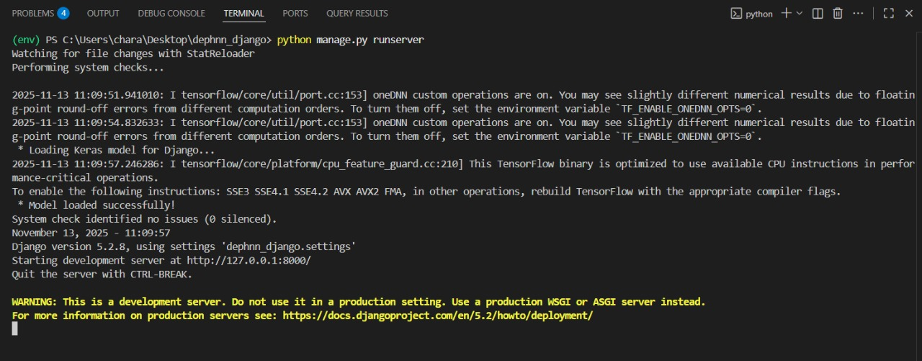 Fig 9.1: Terminal Output Showing Successful Integration of TensorFlow Model in Django
The Fig 9.1 depicts the successful execution of the Django development server with TensorFlow model integration. It confirms that the CNN-LSTM model was loaded successfully and the application is running locally for testing and deployment preparation.
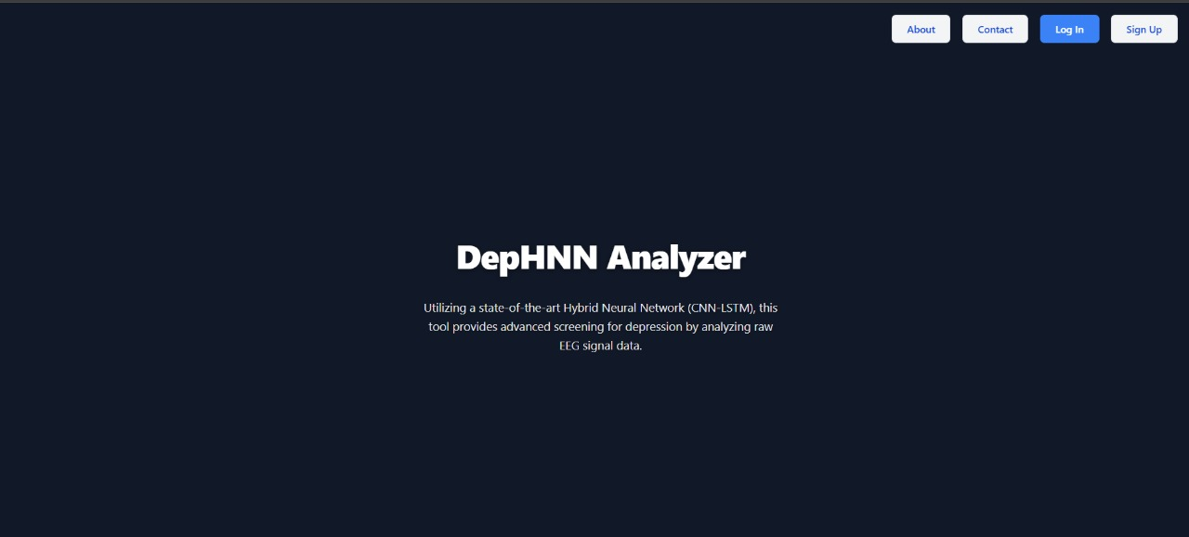Fig 9.2: Homepage of DepHNN Analyzer Web Application
The Fig 9.2 illustrates the homepage of the DepHNN Analyzer web application, which serves as the entry interface for EEG-based depression detection. It highlights the system’s objective of utilizing a CNN-LSTM hybrid neural network for advanced EEG signal analysis.
Fig 9.3: About Us Page of DepHNN Analyzer Web Application
The Fig 9.3 displays the “About Us” section of the DepHNN Analyzer web application, outlining the project’s mission and underlying technology. It highlights the system’s goal of integrating AI for EEG-based depression detection using a CNN-LSTM hybrid neural network.
Fig 9.4: Contact Us Page of DepHNN Analyzer Web Application
The Fig 9.4 represents the “Contact Us” section of the DepHNN Analyzer web application, providing communication channels for user feedback and collaboration. It includes contact details such as the project’s email and GitHub repository for inquiries and technical contributions.
Fig 9.5: EEG Signal Upload and Analysis Interface of DepHNN Analyzer
The Fig 9.5 displays the main analysis interface of the DepHNN Analyzer web application, where users can upload EEG files for depression screening. It allows users to drag and drop EEG data and initiate signal analysis using the integrated CNN-LSTM model.
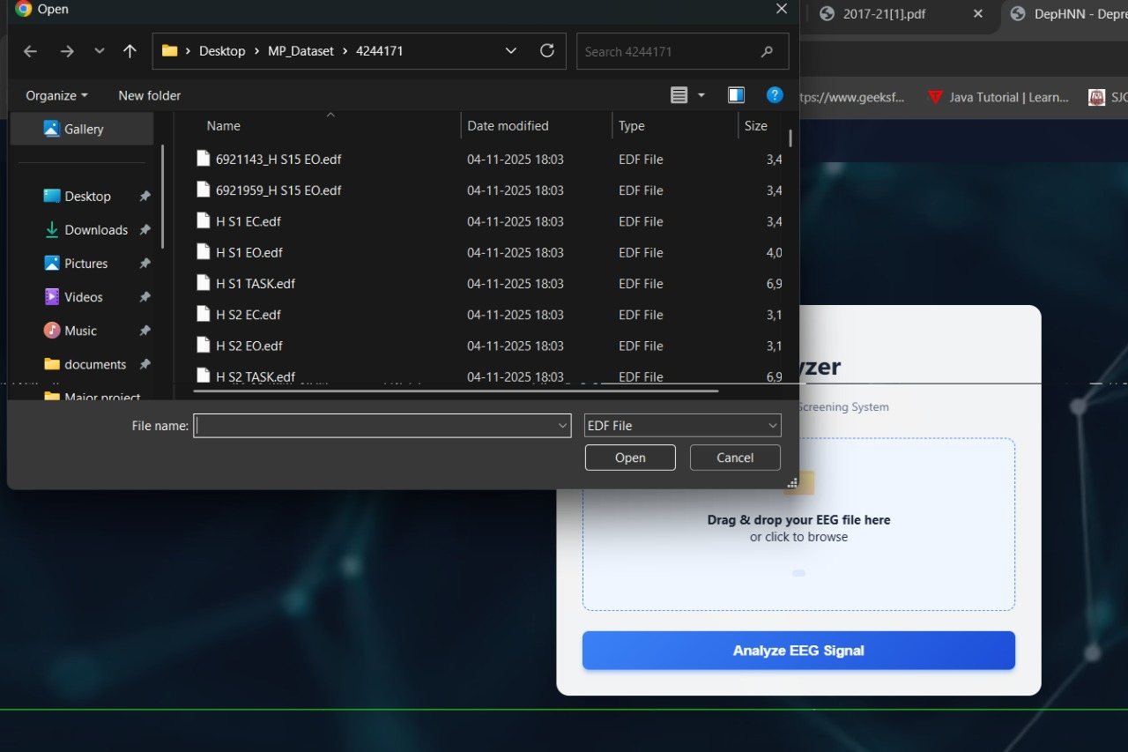Fig 9.6: EEG Data File Selection Interface
The Fig 9.6 shows the file selection window used to choose EEG data files in EDF format from the dataset folder. The selected file will be uploaded to the EEG Analyzer tool for signal analysis.
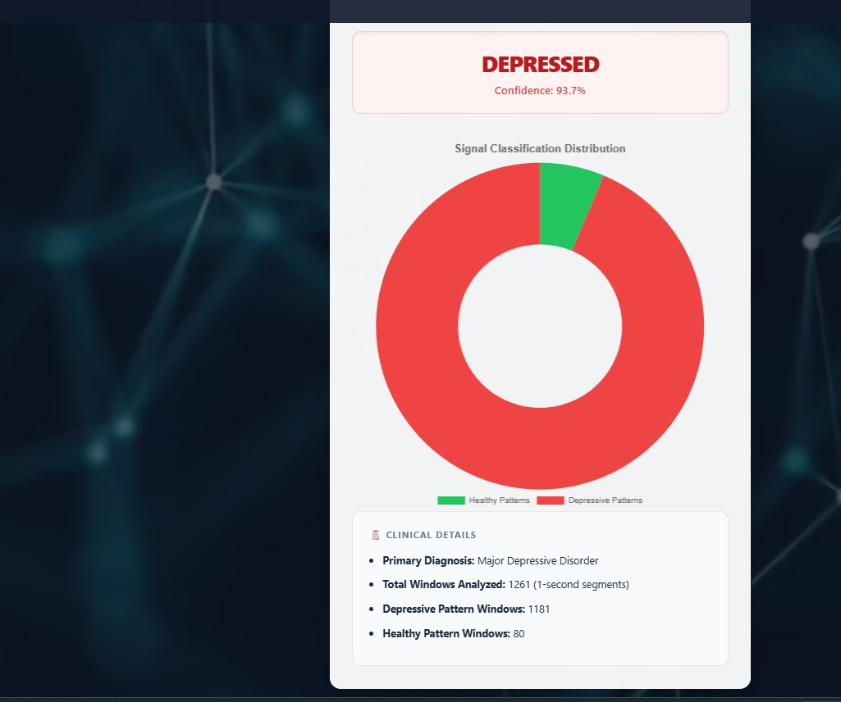Fig 9.7: EEG Signal Classification Result for Depression Detection
The Fig 9.7 shows the EEG analysis result indicating a depressed state with a confidence of 93.7%. The donut chart illustrates the dominance of depressive signal patterns over healthy ones, supported by clinical details summarizing total analyzed segments and diagnostic interpretation.
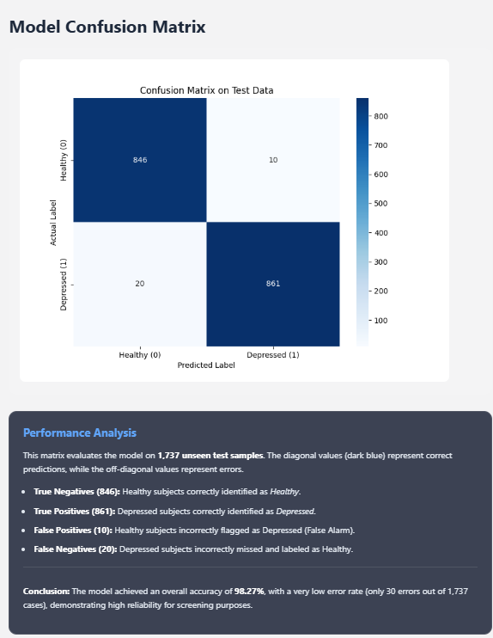
Fig 9.8: Confusion Matrix on Test Data.
The Fig 9.8 illustrates the confusion matrix on test data, confirming the model's ability to distinguish between classes. The heatmap highlights a clear separation of classes with 846 True Negatives (Healthy) and 861 True Positives (Depressed). The low rate of False Positives (10) and False Negatives (20) contributes to a robust accuracy of 98.27%, validating the system's effectiveness in automated depression detection.
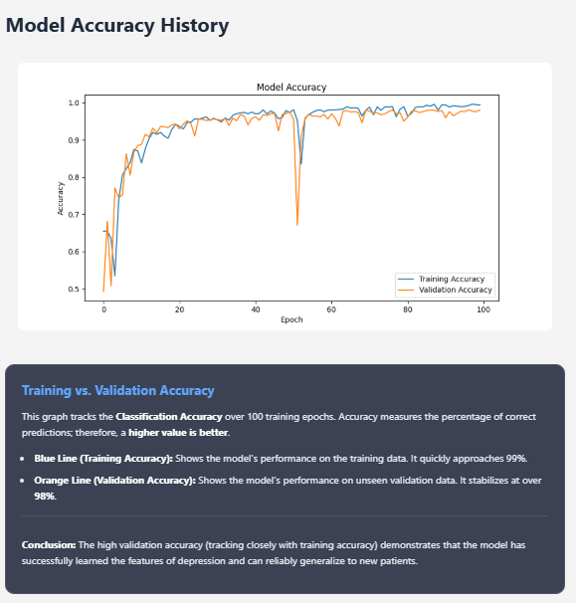
Fig 9.9: Comparison of Training and Validation Accuracy during model training.
The Fig 9.9 displays the training and validation accuracy curves over 100 epochs. The graph shows both metrics rising and stabilizing at high values (>98%), with the validation accuracy tracking the training accuracy closely. This alignment confirms the model is robust, avoiding overfitting while effectively learning to distinguish between healthy and depressed EEG signals.
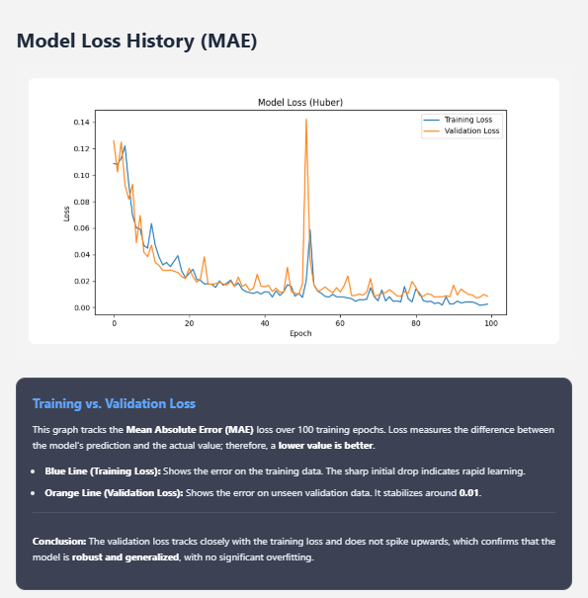
Fig 9.10: Training vs. Validation Loss curves indicating model convergence.
The Fig 9.10 depicts the Model Loss History over 100 training epochs, tracking the Mean Absolute Error (MAE) to evaluate prediction precision. The graph shows a sharp initial decline in error, with both training and validation loss stabilizing at a very low value (around 0.01). This close tracking between the two curves confirms that the model is robust, has minimized prediction errors, and suffers from no significant overfitting.

Fig 9.11: Logout Confirmation Dialog Box
The Fig 9.11 shows a logout confirmation dialog box prompting the user to confirm session termination. It provides two options: “Stay Back” to cancel or “Log Out” to end the session.

